Project Design Phase Proposed Solution

Date | 2 November 2025
Team ID | NM2025TMID00454
Project Name | Calculating Family Expenses using Service Now
Maximum Marks | 2 Marks

Proposed Solution Template:

S.No. | Parameter | Description
1. | Problem Statement (Problem to be solved) | Managing and tracking family expenses manually often leads to confusion, data loss, and inaccurate financial planning. Families need a centralized and automated system to categorize, monitor, and analyze their daily expenses efficiently.
2. | Idea / Solution description | The proposed solution is to build a Family Expense Management System within ServiceNow. The application allows users to record daily expenses, categorize them (e.g., food, utilities, education), set monthly budgets, and view analytical reports. Using ServiceNow forms, tables, and dashboards, users can seamlessly add, edit, and review expense data, ensuring better financial control and transparency.
3. | Novelty / Uniqueness | This solution utilizes ServiceNow’s low-code platform for personal finance management — an uncommon use case for ServiceNow, which is typically used for enterprise ITSM. It leverages workflows, UI policies, and reporting features in a creative, family-oriented context.
4. | Social Impact / Customer Satisfaction | The system promotes financial awareness and planning within families. It helps individuals track their spending habits, avoid overspending, and improve budgeting discipline — contributing to overall household financial stability.
5. | Business Model (Revenue Model) | The system can be offered as a subscription-based personal finance tracking tool built on the ServiceNow platform. It can also be customized for small businesses or community organizations that need shared expense tracking.
6. | Scalability of the Solution | The application can be expanded to include features like expense forecasting using AI, multi-user dashboards for family members, mobile-friendly access, and integration with digital payment systems or banking APIs.

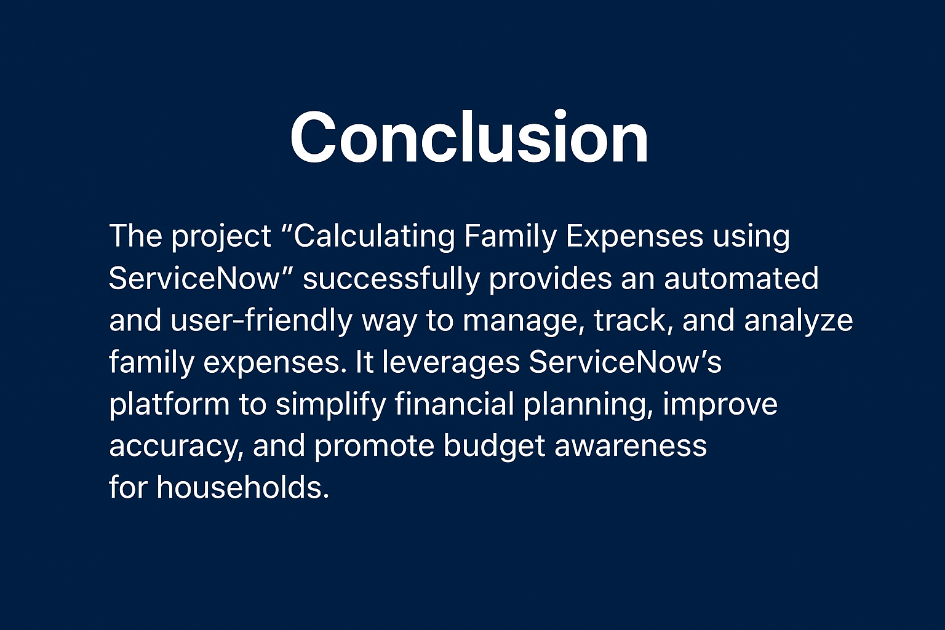
Solution Description:
The “Calculating Family Expenses using ServiceNow” project aims to create a comprehensive platform for recording and analyzing household expenses. Using ServiceNow’s tables and forms, users can enter expense details such as date, category, and amount. Business rules and workflows ensure data integrity, while reports and dashboards provide visual insights into spending trends and budget utilization.
This solution makes expense tracking simple, centralized, and scalable — transforming ServiceNow into a smart family finance assistant.

